**IT222 - Networking 1**

**Introduction to Networks**

**MIDTERM LABORATORY EXAM**

**Group Members:** 1. _____________________________ **Score:** ____________/50

2**.**  _____________________________ **Date:** ____________

3. _____________________________

4. _____________________________

5. _____________________________

6. _____________________________

**Instructor:** ____________________________________________

**Year and Section:** ______________________________________

**Network Topology**

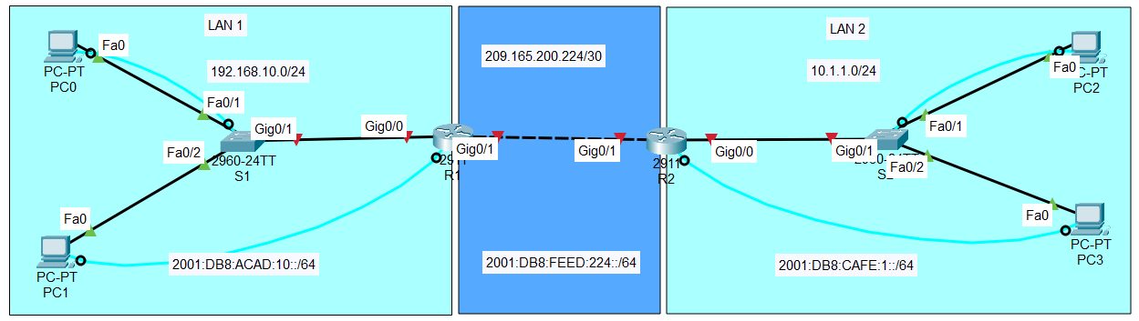

**Objective**

Configure end devices, switches, and routers based on the given topology, including IPv4 & IPv6 addressing, static routing, security configurations, and hostname setup.

**Step 1: Configure IP Addresses for End Devices (PCs)**

**On PC0**

1. Open PC0 and go to **Control Panel > Network and Sharing Center > Change Adapter Settings.** Right-click the **Ethernet** adapter, then choose **Properties.** In the Ethernet Properties, select the Internet **Protocol Version 4 (TCP/IPv4)** and **Protocol Version 6 (TCP/IPv6).**
2. Set IPv4 address: 192.168.10.2
3. Set Subnet Mask: 255.255.255.0
4. Set Default Gateway: 192.168.10.1
5. Set IPv6 address: 2001:DB8:ACAD:10::2/64
6. Set IPv6 Gateway: 2001:DB8:ACAD:10::1

**On PC1**

1. Open PC1 and go to **Control Panel > Network and Sharing Center > Change Adapter Settings.** Right-click the **Ethernet** adapter, then choose **Properties.** In the Ethernet Properties, select the **Internet Protocol Version 4 (TCP/IPv4)** and **Internet** **Protocol Version 6 (TCP/IPv6).**
2. Set IPv4 address: 192.168.10.3
3. Set Subnet Mask: 255.255.255.0
4. Set Default Gateway: 192.168.10.1
5. Set IPv6 address: 2001:DB8:ACAD:10::3/64
6. Set IPv6 Gateway: 2001:DB8:ACAD:10::1

**On PC2**

1. Open PC2 and go to **Control Panel > Network and Sharing Center > Change Adapter Settings.** Right-click the **Ethernet** adapter, then choose **Properties.** In the Ethernet Properties, select the **Internet** **Protocol Version 4 (TCP/IPv4)** and **Internet** **Protocol Version 6 (TCP/IPv6).**
2. Set IPv4 address: 10.1.1.2
3. Set Subnet Mask: 255.255.255.0
4. Set Default Gateway: 10.1.1.1
5. Set IPv6 address: 2001:DB8:CAFE:1::2/64
6. Set IPv6 Gateway: 2001:DB8:CAFE:1::1

**On PC3**

1. Open PC3 and go to **Control Panel > Network and Sharing Center > Change Adapter Settings.** Right-click the **Ethernet** adapter, then choose **Properties.** In the Ethernet Properties, select the Internet **Protocol Version 4 (TCP/IPv4)** and **Protocol Version 6 (TCP/IPv6).**
2. Set IPv4 address: 10.1.1.3
3. Set Subnet Mask: 255.255.255.0
4. Set Default Gateway: 10.1.1.1
5. Set IPv6 address: 2001:DB8:CAFE:1::3/64
6. Set IPv6 Gateway: 2001:DB8:CAFE:1::1

**Step 2: Configure Switch VLAN Interface**

**On Switch S1 (Left-side switch).** Connect the **console cable** to the **switch console port** and to the **PC** **USB port**.

1. On the selected PC, open **Putty/Tera Term** terminal emulation software, then select the **Serial** option with the correct **Com** port to open the **CLI** of the Switch **S1.**
2. Enter configuration mode:

enable

configure terminal

1. Set hostname:

hostname S1

1. Set dual IP configuration

sdm prefer dual-ipv4-and-ipv6 default

1. Configure VLAN 1 interface for management:

interface vlan 1

ip address 192.168.10.4 255.255.255.0

ipv6 address 2001:DB8:ACAD:10::4/64

no shutdown

exit

ip default-gateway 192.168.10.1

ip default-gateway 2001:DB8:ACAD:10::1

1. Save the configuration:

Copy running-config startup-config

**On Switch S2 (Right-side switch).** Connect the **console cable** to the **switch console por**t and to the **PC USB port**.

1. On the selected PC, open **Putty/Tera Term** terminal emulation software, then select the **Serial** option with the correct **Com** port to open the **CLI** of the Switch **S2.**
2. Enter configuration mode:

enable

configure terminal

1. Set hostname:

hostname S2

1. Set dual IP configuration

sdm prefer dual-ipv4-and-ipv6 default

1. Configure VLAN 1 interface for management:

interface vlan 1

ip address 10.1.1.4 255.255.255.0

ipv6 address 2001:DB8:CAFE:1::4/64

no shutdown

exit

ip default-gateway 10.1.1.1

ip default-gateway 2001:DB8:CAFE:1::1

1. Save the configuration:

Copy running-config startup-config

**Step 3: Configure Router Interfaces**

**On Router R1 (**Connect the **console cable** to the **router console por**t and to the **PC** **USB port**.)

1. On the selected PC, open **Putty/Tera Term** terminal emulation software, then select the **Serial** option with the correct **Com** port to open the **CLI** of the Router **R1.**
2. Set hostname:

enable

configure terminal

hostname R1

1. Configure **GigabitEthernet 0/0** (Connected to Switch S1)

interface Gig0/0

ip address 192.168.10.1 255.255.255.0

ipv6 address 2001:DB8:ACAD:10::1/64

no shutdown

exit

1. Configure **GigabitEthernet 0/1** (Connected to R2)

interface Gig0/1

ip address 209.165.200.225 255.255.255.252

ipv6 address 2001:DB8:FEED:224::1/64

no shutdown

exit

1. Save configuration:

Copy running-config startup-config

**On Router R2 (**Connect the **console cable** to the router **console por**t and to the **PC** **USB port**.)

1. On the selected PC, open **Putty/Tera Term** terminal emulation software, then select the **Serial** option with the correct **Com** port to open the **CLI** of the Router **R2.**
2. Set hostname:

enable

configure terminal

hostname R2

1. Configure **GigabitEthernet 0/1** (Connected to R1)

interface Gig0/1

ip address 209.165.200.226 255.255.255.252

ipv6 address 2001:DB8:FEED:224::2/64

no shutdown

exit

1. Configure **GigabitEthernet 0/0** (Connected to Switch S2)

interface Gig0/0

ip address 10.1.1.1 255.255.255.0

ipv6 address 2001:DB8:CAFE:1::1/64

no shutdown

exit

1. Save configuration:

Copy running-config startup-config

**Step 4: Configure Static Routes**

**On Router R1**

Ipv6 unicast-routing

ip route 10.1.1.0 255.255.255.0 209.165.200.226

ipv6 route 2001:DB8:CAFE:1::/64 2001:DB8:FEED:224::2

**On Router R2**

Ipv6 unicast-routing

ip route 192.168.10.0 255.255.255.0 209.165.200.225

ipv6 route 2001:DB8:ACAD:10::/64 2001:DB8:FEED:224::1

**Step 5: Security Configurations (Switches 1 & 2, Routers 1 & 2)**

**Set Privilege Mode Password**

enable secret cisco123

**Set Console Password**

line console 0

password conpass

login

exit

**Set VTY Password**

line vty 0 15

password vtypass

login

exit

**Set MOTD Banner**

banner motd #Unauthorized access is prohibited!#

**Encrypt Passwords**

service password-encryption

**Save Configuration**

Copy running-config startup-config

**Step 6: Verify Configuration**

1. **On R1 and R2**
   * show running-configuration
2. **On S1 and S2**
   * show running-configuration

**Step 7: Test Connectivity**

1. **Use the Ping Command**
   * From PC0, ping PC2 (10.1.1.2)
   * From PC0, ping PC2 (2001:DB8:CAFE:1::2)
   * From PC2, ping PC0 (192.168.10.2)
   * From PC2, ping PC0 (2001:DB8:ACAD:10::2)
   * From PC1, ping PC3 (10.1.1.3)
   * From PC1, ping PC3 (2001:DB8:CAFE:1::3)
   * From PC3, ping PC1 (192.168.10.3)
   * From PC3, ping PC1 (2001:DB8:ACAD:10::3)
2. **Check the Routing Table**
   * On R1: show ip route
   * On R1: show ipv6 route
   * On R2: show ip route
   * On R2: show ipv6 route